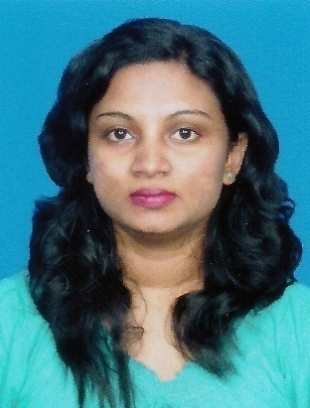

**BIO DATA OF DONA GANGA DEVI HETTIARACHCHI**

**Name In Full** - Dona Gangadevi Hettiarachchi

**Address**  - No. 76 1/1, Alakeshwara road,

**Athul Kotte**.

**Tel** - 077 4190518

**Date Of Birth -** 27-11- 1976

**Sex** - Female

**Nationality** - Sri- Lankan

**Religion** - Budhist

**Civil Status** - Married

**School Attented** - All Saints College- Colombo -08

Presidents College,

Sri Jayawardenapura-Kotte.

**Educational Qualifications-Succesfully Completed the GCE O/Level Examination in 1992/93**

Subject Grade

Budhism Credit Pass

Sinhala Credit Pass

English Credit Pass

Commerce and Acounts Credit Pass

Mathematics Simple Pass

Social Studies Simple Pass

**Succesfully Completed the GCE Advance Level Examination in 1995.**

Subject Grade

Accountancy Credit Pass

Commerce Simple Pass

Economics Simple Pass

Logic Simple Pass

**Professional Qualifications**

Followed a typing course at Polytechnic –

Wellawatte.

Have a fair knowledge in Lotus -123, Word Perfect, Professional Writer,

Microsoft Windows and Mirosoft Excel.

**Work Experience**

I was employed at Ceylon Carriers( Travel Services) Ltd as a Trainee Junior Secretary to the Chairman/Managing Director for a period of 2 Years ( during 1996-1998)

Was employed at Quickshaws Tours limited as Secretarial Computer Operator to the Managing Director from 1999-2001.

Joined Quickshaws Tours Limited after 5 yearsas a Secretary to the Managing Director and handling every correspondence and Personnel Department’s correspondence from 2006 - 2008.

Presently working at Quickshaws Limited as a Secretary , handling all correspondences,handling tour inquiries and hotel reservations from 2010.

Handling the purchasing of material and equipment for the ongoing refurbishment work for the 2 hotels in Anuradhapura.

Handling Personal Department’s correspondence as well.

**Extra Curricular Activities-**

Was a member of the College Western Band

Was the Secretary of the Budhist Society

Was a member of the Sinhala literary Society and photographic Society

Member of the college dancing troupe which represented the college at National games festival.

Was a member of the College Netball Team.

Was a member of the College Swimming Team.

**Non Related Referees** - Mr. Mahesh Deheragoda

Managing Director

Levlin Engineering Pvt.,Ltd.,

12, Balahenamulla Rd.,

Colombo 06.

Tel: 7392993

Ms. Delreen Meedin

Secretary

Shermons Logistics

Barnes Place

Colombo 08.

Tel: 077 3635569

I do hereby certify that the above particulars are true and accurate to the best of my ability.

**Ganga Hettiarachchi**

Applicant